Отчет по курсовой работе  
Задание 6

# Описание

Программа по тестовому заданию перемещает

# Рабочий экран

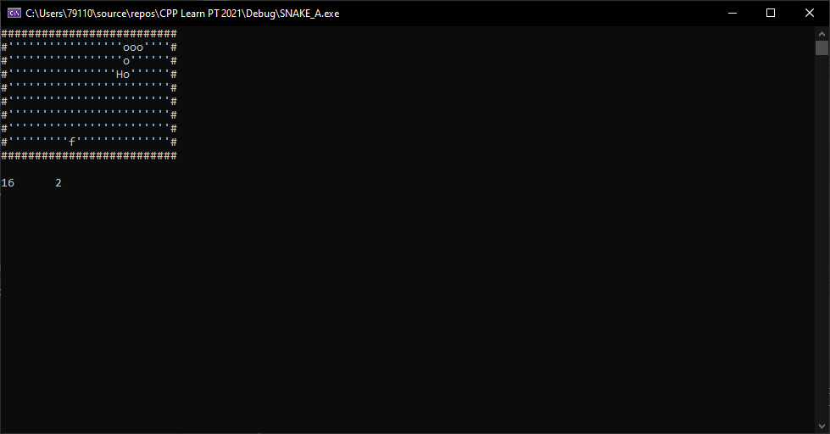

Рисунок 1. Змейка на поле

# Состав программы

Проект содержит 2 файла хедеров и 2 файла кода:  
inputs.h  
test_inputs.h  
inputs.cpp  
test_inputs.cpp

## inputs.h

#pragma once

#if defined _INPUTS_SET

#define _INPUTS_SET

#endif //

#define ESC_KEY 27

enum Actions

{

KEY_UP,

KEY_DN,

KEY_RT,

KEY_LT,

EXIT,

UNDEF,

OP1,

OP2,

OP3

};

int read_input();

## inputs.cpp

#include <conio.h>

#include <ctype.h>

#include "inputs.h"

struct KeyMapItem

{

unsigned int key;

char action;

};

static KeyMapItem keyMap[]

{

{75, KEY_LT},

{77, KEY_RT},

{72, KEY_UP},

{80, KEY_DN},

{'A', KEY_LT},

{'D', KEY_RT},

{'W', KEY_UP},

{'S', KEY_DN},

{'Ф', KEY_LT},

{'В', KEY_RT},

{'Ц', KEY_UP},

{'Ы', KEY_DN},

{'0', EXIT},

{ESC_KEY, EXIT},

{'1', OP1},

{'2', OP2},

{'3', OP3}

};

int read_input()

{

int mapSize = sizeof(keyMap) / sizeof(keyMap[0]);

int ch;

ch = _getch();

ch = toupper(ch);

#if _DEBUG

_putch(ch);

_putch('\r'); // Carriage return

_putch('\n'); // Line feed

#endif

char action = UNDEF;

for (int i = 0; i < mapSize; i++)

{

if (ch == keyMap[i].key)

{

action = keyMap[i].action;

break;

}

}

return action;

}

## test_inputs.h

#pragma once

int test_inputs();

## test_inputs.cpp

#include <iostream>

#include <conio.h>

//#include <stdio.h>

//#include <string.h>

//#include <cstdlib>

#include "test_screen.h"

#include "inputs.h"

void do_up()

{

std::cout << "KEY UP";

}

void do_dn()

{

std::cout << "KEY DN";

}

void do_rt()

{

std::cout << "KEY RT";

}

void do_lt()

{

std::cout << "KEY LT";

}

void do_xt()

{

std::cout << "KEY EXIT";

std::exit(EXIT_SUCCESS);

}

void do_ud()

{

std::cout << "KEY UNDEFINED";

}

void do_op1()

{

//test_screen();

std::cout << "KEY OP1\t";

move_snake_test();

}

void do_op2()

{

//test_screen();

std::cout << "KEY OP2\t";

move_snake_test1();

}

void do_op3()

{

//test_screen();

std::cout << "KEY OP2\t";

move_snake_test2();

}

using actFx = void (*)();

struct ActMapItem

{

char key;

actFx action;

};

static ActMapItem actMap[]

{

{KEY_UP, do_up},

{KEY_DN, do_dn},

{KEY_LT, do_lt},

{KEY_RT, do_rt},

{EXIT, do_xt},

{UNDEF, do_ud},

{OP1, do_op1},

{OP2, do_op2},

{OP3, do_op3}

};

int test_inputs()

{

int actMapSize = sizeof(actMap) / sizeof(actMap[0]);

char ch;

void (* pAction)();

while (true)

{

ch = read_input();

for (int i = 0; i < actMapSize; i++)

{

if (ch == actMap[i].key)

{

system("CLS");

#if defined _DEBUG

std::cout << actMapSize << '\t' << i << '\n';

#endif

pAction = actMap[i].action;

pAction();

break;

}

}

}

return 0;

}